Jureschi Magda

Group 258

SERVICE ORIENTED ARCHITECTURE

DOCUMENTATION

# 1. Problem statement

The delivery application provides the following functionalities:

* Show all customers from the database and their data;
* Add a new customer.

**2. Architecture overview**

The entire application is based on the Service Oriented Architecture. There are two main components: **SoaAppApplication** (the server)and **SoaClientSideApplication** (the client). The SoaAppApplication system is a web application that uses web services exposed by an application server regarding persons and data related to their address (*https://jsonplaceholder.typicode.com/users*). This server provides information persons and their addresses, like name, email, zipcode, city, street and so on.

SoaAppApplication connect to this application server in order to get provided data and to expose web services. The system presents the operations: get all available persons and their adresses, get persons by id and add a new person. In other words, this system is a web service that offers REST services. The SoaClientSideApplication is the system which consumers the services from SoaAppApplication and it is a web application that provides the functionalities described at section 1.

The entity or data which is passed between services is **Person**, which has: id, name, email, street, suite, city and zipcode.

Based on the experience from work environment, SprintBoot application are directly deployed on the server.

As SpringBoot offers out-of-the-box deployable artifacts, there is no need for a docker container and the usage of *mvn clean install* command creates a jar that contains the web server itself, as well as the app.

**3. BMPN Diagrams**

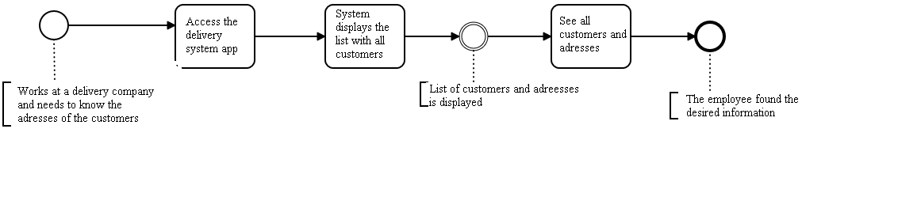

Figure 1 Show all customers

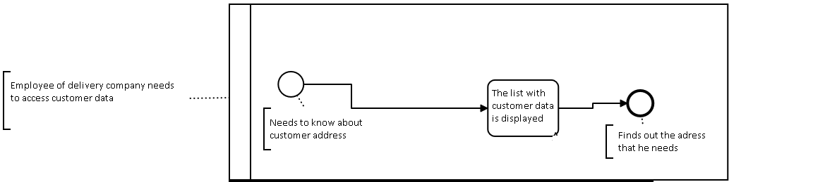

Figure 2 Actions of users

**4. BMM diagram**

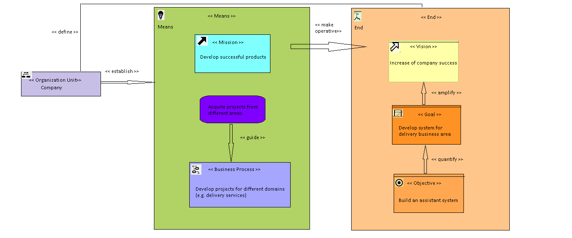

**5. SOA ML Diagrams**

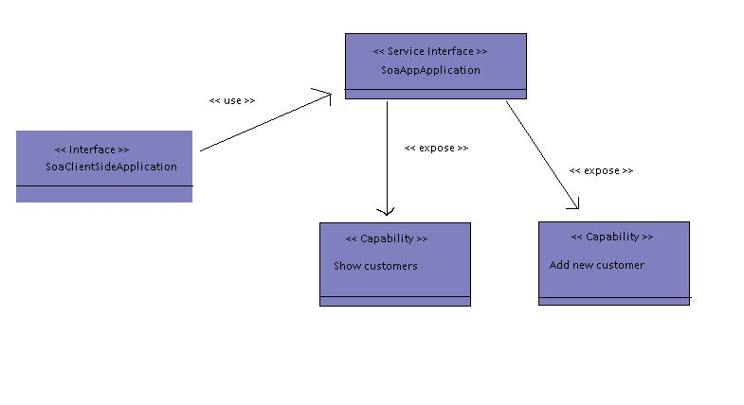

Figure 3 Service Interface

**6. Message Façade Pattern**

